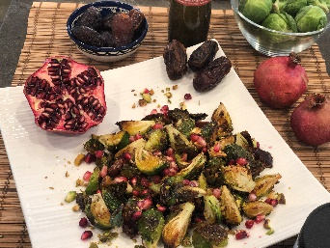

Roasted Brussel Sprouts with Rosemary, Garlic
and 18 Year Aged White Balsamic
By Debbie Kornberg

(Serves 4-6)
This easy to prepare dish and has a wonderful tangy flavor when using the 18 year aged white balsamic! Perfect for a family meal or when entertaining!

Ingredients:
1 bag. of Brussel Sprouts, About 2 lbs. cut in half or quartered
2 Tbsp. SPICE + LEAF Galili Premium Israeli Olive Oil
1 Tbsp. SPICE + LEAF Rosemary Garlic Salt
6 - 8 Dates, pitted & chopped
1 - 2 Tbsp. SPICE + LEAF 18 Year Aged White Balsamic
1/4 cup Pistachios, toasted, chopped
1/8 cup Pomegranate seeds

Instructions:
Preheat oven to 425 degrees.
Wash Brussel sprouts and pat dry.
Using a cutting board cut Brussel sprouts in half or quarters.
Place Brussel sprouts in baking pan, (glass or aluminum) and drizzle olive oil over Brussel sprouts and toss so they are well coated. Sprinkle Rosemary Garlic Salt on Brussel sprouts and toss well again.
Place in oven and roast for about 25 - 30 minutes or until Brussel sprouts are crispy and toasty brown on the outside. Remove from oven when done. Add chopped dates and mix in. Drizzle 18 Year Aged White Balsamic on Brussel sprouts and toss well. Sprinkle toasted pistachios and pomegranate seeds. Yum!

